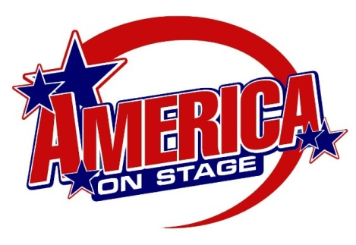
America On Stage 2026!
Director’s Packet
Thanksgiving Point Clogging
& Power Tap Championships March 6-7, 2026

We’re SO EXCITED you are registered with America On Stage!
This packet contains all the information you need to compete at America On Stage and have a great time.
Take note of the deadlines of registration, our updated schedule, and how we do our awards below.
If you have any questions, please let us know and we’ll see you on stage!
Robbie Walker, Leah and Dan Coffman, Hailey and Adison Hillstead and all America On Stage Staff

REGISTRATION CONFIRMATION & DEADLINES
You can check your registration online at www.americaonstage.org.
Click on “Online Registration” and then “Registration Summary” to see all your entries. Please double check it to guarantee all your dancers are registered correctly. Take note of the following deadlines:

February 6, 2026
Mid-Registration Deadline. Registration is still available online at Mid-Registration prices.
Registration changes are still made online until the date below.

February 17, 2026
All Online Registration closes on this date. After this date, there is no more registration taken online.
All Registration Changes online are also no longer allowed after this date.
You can Email us at competitions@americaonstage.org to see if we have any more space at add registration.
Any and all registration changes, additions (if able), or cancellations need to be made by Emailing competitions@americaonstage.org.

February 19, 2026
Final Program Posted Online on this date. Check the competition page after 3:00 pm to see all the programs! No more dance solos, duos/trios registration is taken after this date due to awards not being able to be ordered in time.
Updated Schedule
Listed below is our updated schedule based upon all registration received.
Please let your dancers know the updated times below.
We will post the Final Programs online 15 days prior to the event online.
Friday, March 6, 2025
Clogging Championship – Professional All Categories

8:30 AM | Champ Duets
8:45 AM
9:00 AM
9:15 AM
9:30 AM
9:45 AM | Champ Sh/Ac Duets
10:00 AM
10:15 AM | Champ A Cappella
10:30 AM
10:45 AM | Champ Freestyle
11:00 AM
11:15 AM | Champ All-Around Solos
11:30 AM
11:45 AM
12:00 PM | Champ Freestyle Dance Off
12:15 PM | Pro All-Around Solos
12:30 PM
12:45 PM
1:00 PM
1:15 PM
1:30 PM
1:45 PM | Pro Freestyle
2:00 PM
2:15 PM
2:30 PM
2:45 PM
3:00 PM | Pro A Cappella
3:15 PM
3:30 PM
3:45 PM | Pro Choreographed Solo
4:00 PM | Pro Short/A Cap Duets
4:15 PM
4:30 PM
4:45 PM
5:00 PM | Pro Duets
5:15 PM
5:30 PM
5:45 PM
6:00 PM
6:15 PM | Pro Dance Off
6:30 PM
6:45 PM
7:00 PM | Champ /Pro Teams
7:15 PM
7:30 PM
7:45 PM
8:00 PM
8:15 PM
8:30 PM
8:45 PM
9:00 PM
9:15 PM
9:30 PM
9:45 PM
10:00 PM
10:15 PM

Saturday, March 7, 2026
Clogging Novice - Advanced Categories
10:00 AM | Beg Ind/Duets
10:15 AM
10:30 AM
10:45 AM
11:00 AM | Beg Teams
11:15 AM
11:30 AM
11:45 AM
12:00 PM | Beg Awards
12:15 PM | Novice Ind/Duets
12:30 PM
12:45 PM | Novice Teams
1:00 PM
1:15 PM
1:30 PM | Novice Awards
1:45 PM | Intermediate Ind/Duets
2:00 PM
2:15 PM
2:30 PM
2:45 PM
3:00 PM
3:15 PM | Intermediate Teams
3:30 PM
3:45 PM
4:00 PM
4:15 PM
4:30 PM
4:45 PM | Intermediate Awards
5:00 PM | Advanced Teams
5:15 PM
5:30 PM
5:45 PM
6:00 PM
6:15 PM
6:30 PM | Advanced Ind/Duets
6:45 PM
7:00 PM
7:15 PM
7:30 PM
7:45 PM
8:00 PM
8:15 PM
8:30 PM | Advanced Dance Off
8:45 PM | Awards
Remember times are line-up estimates and you may compete a little bit later as final registration comes in. Please be ready to compete at least 60 minutes before your scheduled time.
Things to know!
Before you come to the event…
Make all registration changes online now!
Once the final program is posted, changes will need to be made by Email or at the event. We would love to have all changes done BEFORE the final program is posted online. Please look at your registration online with your dancers and ensure it is all correct.
Payment & Studio Grants
Our way to help you and your studio!
We are excited our Studio Grant program has worked so well. Each qualifying studio can receive up to 10 % of their registration at each event returned to them as a studio grant. It's our way of assisting studios to grow and thanking you for attending! Remember! Studios must be FULLY paid 4 weeks prior to qualify for a grant. Check online to see your current balance, correct any incorrect charges, and pay any owed registration!

Director’s Corner Online
Go to americaonstage.org and click on Director’s Corner to access your Studio Grants, All Programs, payments, registration changes, Music Upload information, Awards information, Competition info and all Results and more. See the dates on each competition page for when Program post.

–

–
Things to know!
Once you are at the event…
Numbers
Only Clogging Individuals, Clog Short Duets, and Clog A cap Duets will need to wear a number.
Pick up these at the numbers table.
Director's Packets
Please pick up your Director's Packet at the Registration table once at the event. The packet will have a personalized program with the times for only your routines, a full program, a director's badge along with all your information.
.

No Admission
We offer no admission charge for anyone to enter. Bring everyone!
Competition Live
Go to americaonstage.org on your phone and see Competition Live! Access Programs and results real time! and more.

Age Division Awards Ceremonies
All Events will be posted online and awards can be picked up after being iosted at the awards table.
All OVERALL Awards will be announced when each level's teams are done
SUPERStars
Master Soloists
Judges Choice teams
Overall Teams
Overall Studios

Overall Awards Ceremonies
We award the top 5 Overall Teams in EACH level!
We awards the top choice for Judges Choice in EACH level!
We award the top 3 Overall Winning Studios in EACH level!
We award the top 5 Overall Individuals and Duets! (Either by High Score or Dance Off).

Overall awards will be announced when each level's events are done. Check the Program for exact times

Go to americaonstage,org to see our amazing awards!

Dance Offs!
There are dance offs this year!
All 1st place High Gold winners in Clogging Adv and Champ will compete in their dance off after their levels.
Clogging Pro Dance off will happen after their individual levels

------------------------------------------

Location
Thanksgiving Point Show Barn
BEAUTIFUL VENUE- Beautiful Full Stage!
We are excited to return to the beautiful Thanksgiving Point Show Barn! We will dance in the auditorium with a large stage. There will be a dressing room for women and one for men. We have no admission and encourage everyone to come cheer and have a great time! It’s going to be great.

Questions?
Contact our competition promoters with any questions
Contact us with any questions
Promoter: Tara Osborn, Maria Tucker
Promoter’s Phone: 801-885-8402, 801-224-8334
Promoter Email: foothillcloggers@gmail.com, rmexpress@gmail.com
E-mail: competitions@americaonstage.org
Website: www.americaonstage.org
America On Stage HQ Phone: 801-224-8334

Video Taping is allowed in the back of the facility.
Competition directors assume no responsibility for lost or stolen items.

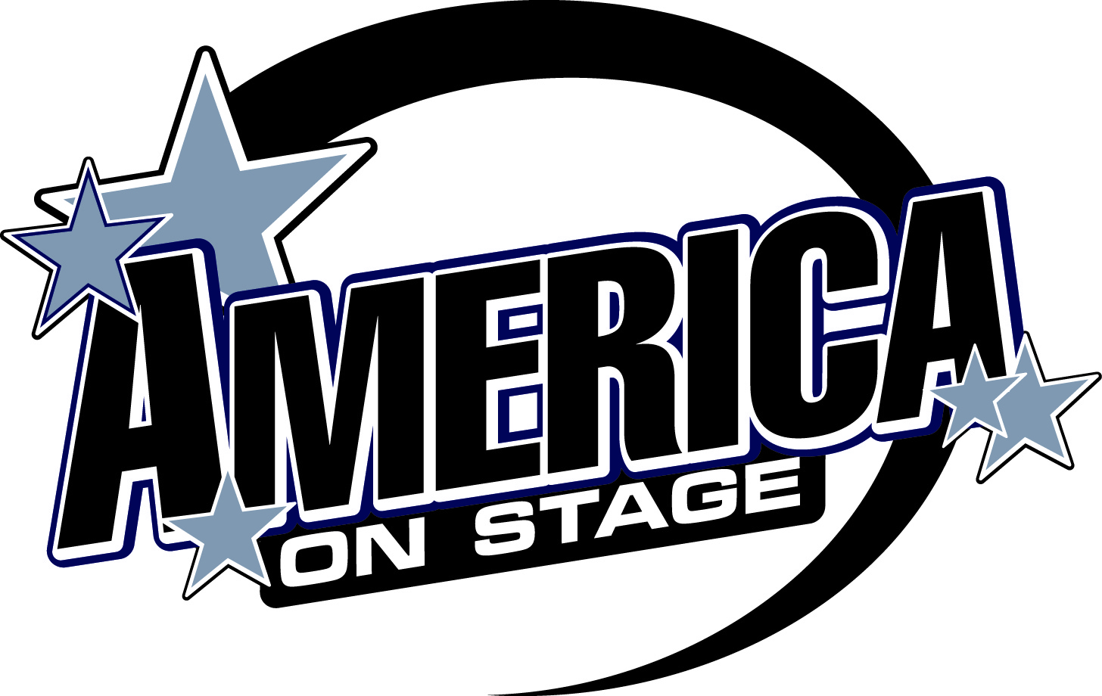
America On Stage Awards
America On Stage events feature an award for every dancer and every team!
At America on Stage, we believe every dancer, team, and director should be highly recognized for their excellent achievement. Accordingly, we offer the best awards program anywhere!
- Every dancer receives a Competition Medallion to display all their results
- Every dancer receives an Award Pin for their medallion for every event competed (including team).
- Every studio receives one Large Trophy for their team awards.
- Every studio receives a Team Plate for their large studio trophy for every team event competed.
- At a special Awards Ceremony at the end of every level (immediately after all scores have been tallied – check the program) we present Overall Awards!

Here's how it works:
- After you compete, age division results are posted online at americaonstage.org and on the posting wall!
- All winners get an awards pin at the awards table for each event competed (including teams) and should pick up their pins themselves.
- A special Team Place Plate to go on their Large Studio Trophy is given to the director at the awards table at the end of the day with their score sheets at the awards table.

AGE DIVISION AWARDS
All Age Division awards are posted online at americaonstage.org under “Competition Live” and on posting wall.

Clogging Novice, Beginning Intermediate, and Advanced
We award all dancers based on their score!
All Dancers awarded either a 1st, 2nd or 3rd based upon their score.
Dance Novice, Beginning Intermediate, and Clogging Championship
We award all dancers based on their score!
All Dancers awarded either a 1st HIGH GOLD, 1st, 2nd or 3rd based upon their score.
All Dancers who score over 98% of their possible score receive 1st place HIGH GOLD

Dance Advanced, Clogging Professional
One 1st, one 2nd, One 3rd , One 4th, One 5th and High Gold Ratings
Highest Score is awarded 1st, next highest 2nd, and next highest 3rd etc...
All Dancers who score over 98% of their possible score receive HIGH GOLD
HIGH GOLD Award
The HIGH GOLD award also allows for each dancer who might be dancing alone in their age division to compete and see if they can score high enough to earn a High Gold. See following program pages for more info.
DANCE QUEEN/KING Awards
All Queen awards are announced from the stage! All Queen winners are awarded a large trophy. All 1st place Queen winners also receive a sash and tiara. At large events, we will post the results online and you can pick up your awards early at the awards table.
All Standard solo and duet results are posted on the results wall (not announced).
All standard winners receive a trophy at the awards table.
America On Stage OVERALL Awards
OVERALL AWARDS CEREMONIES!
SUPERStar Awards
There are TWO SUPERStar awards. Every time you compete, you earn points which are tallied today and all year long.  TODAY’S SUPERStars  The dancers with the most individual points at TODAY’S EVENT in each level are called up  on stage and awarded as TODAY’S SUPERStars.  OVERALL’S SUPERStars  At Nationals at Lagoon, we will award the highest scoring dancer with the most combined points as the Overall Individual, Duet, and Team SUPERStars! See the rankings online | Today's SUPERStars

Master Soloist
In Clogging's All-Around Solos,  a person winning 1st places in all 5 solos in  1 level are awarded Master Soloist. | Today's Master Soloists (Clogging)
Nationals Hot Ticket Invitations
& 1st Place Winning Teams
Teams who win 1st place will be recognized during the Overall Awards ceremony. All Dance teams are invited to Nationals. All Clogging 1st place teams will receive a Hot Ticket invitation to compete at Nationals at Lagoon!

Judges Choice Team
Each judge can award up to 5 team routines in each level as their favorite team dance today  .  We will announce all teams who receive Judges Choice nominations.  The team with the most nominations will be awarded as the Judges Choice in that level. | Today's Judges Choice Team

OVERALL TEAMS
In every level, the top 5 highest scoring teams are awarded  Overall Team Trophies!  In our Advanced Dance categories, we also award the  Overall Jazz, Hip Hop, Contemporary & Lyrical Team if registration dictatates!
  Today's Overall Teams
OVERALL STUDIOS
In every level, the top 3 studios with the most wins are awarded  Overall Studio Trophies!
  Today's Overall Studios

America On Stage Online!
RESULTS
and
PROGRAM
are online!
-----------------------------------
Get all your results on your phone!
Go to
www.americaonstage.org
Click on
"Competition Live"

Skip the lines to see your results on the awards posting wall.
See your results anywhere, anytime, with any
smartphone, tablet or laptop!
See results listed by dancer, director and category.
30 minutes after each division’s completion, results are listed online.
Get the programs online, and all SUPERStars who won today!
America On Stage
High Gold Awards Explanation
Dance Novice, Beginning, Intermediate and Advanced Levels
Clogging Championship and Pro Levels

Our newest awards are called HIGH GOLD! Here’s how they work

LEVELS OFFERED:
HIGH GOLD is offered in all levels of Dance and Clogging Championship and Clogging Pro. All other levels still offer multiple awards as has been done before (All Dancers receive either a 1st, 2nd or 3rd place based upon their score.)

Dance Novice, Beginning, Intermediate and Clogging Championship are awarded with BOTH awards below:
MULTIPLE AWARDS – All Dancers receive either a 1st, 2nd or 3rd place based upon their score.
HIGH GOLD – Each dancer that scores 98% or higher is also awarded a HIGH GOLD

If you are by yourself, or competing against others, you strive not only to get a first place score (29.2 or higher), but you also dance to score a first place HIGH GOLD (29.5 or higher).

It is possible to see an age division similar to one below in Dance Intermediate or Clogging Champ

Dancer A 1st Place HIGH GOLD Dancer A has scored a 29.6
Dancer B 1st Place HIGH GOLD Dancer B has scored a 29.55
Dancer C 1st Place Dancer C has scored a 29.1
Dancer D 1st Place Dancer D has scored a 28.8
Dancer E 2nd Place Dancer E has scored a 28.4
Dancer F 3rd Place

Dance Advanced and Clogging Pro are awarded with BOTH awards below:
SINGLE AWARDS – One 1st, one 2nd one 3rd, one 4th, one 5th. Dancers all compete against each other.
HIGH GOLD - Each dancer that scores 98% or higher is also awarded a HIGH GOLD

If you are by yourself, or competing against others, you strive not only to get a first place score (29.2 or higher), but you also dance to score a first place HIGH GOLD (29.5 or higher).

It is possible to see an age division similar to one below

Dancer A 1st Place HIGH GOLD Dancer A has scored a 29.9
Dancer B 2nd Place HIGH GOLD Dancer B has scored a 29.8
Dancer C 3rd Place HIGH GOLD Dancer C has scored a 29.7
Dancer D 4th Place Dancer D has scored a 29.4
Dancer E 5th Place Dancer E has scored a 29.3

We hope this new awards system rewards all those who work so hard, dance so well, and strive so much to earn the very best awards possible.

We look forward to your comments on this new awards system and can’t wait to see you at America On Stage where the Magic of a Win takes Center Stage!
Welcome to America On Stage!
What makes America On Stage events so much fun for Directors and Students?
FAST – We run our event very quickly and efficiently. No waiting around. We post a detailed schedule online with dances down to the minute. Show up about one hour before your scheduled time and dance on stage. We post our awards as soon as they are ready and announce our overall awards after each level so you need not spend an entire day at an event! It’s incredible popular and fun to participate with very little waiting around!

FUN – We include fun activities in each event. As we can be often a few minutes ahead, we play games with the audiences, dance group numbers such as the Cha Cha Slide and hold our events at such fun events as Lagoon Amusement park and Knott’s Berry Farm where you can play after competing! Come see the fun at America On Stage!

FAIR – We do all we can to get well qualified and impartial judges. All our staff are trained and work hard to ensure each team is treated fairly and each team has all the opportunities to shine on stage!

FRIENDLY – With a staff trained to help, and our team designed to assist in whatever way we can, we strive to make your competition experience amazing. Ask any staff person for help and we will do all we can to make your wishes happen.

AWARDS – With an awards system designed to be second to none, we boast some of the most fun awards ever! Every dancer is awarded for every event they dance. All dancers in our lower level receive either a 1st, 2nd or 3rd place for EVERY EVENT the dance. We award Overall Teams in EVERY LEVEL and award studios that win the most in EVERY LEVEL as well. At our State Championships, we award the highest scoring team, soloist, duo, and trio in each category the titles of State Champions. At Nationals at Lagoon (the WORLD’S LARDEST Dance competition), we award every dancer with an award for each event danced, Overall Teams, Overall Studios, Directors of the Year, and All-Americans, and MVP National Champions. This is something you just don’t want to miss!

STUDIO GRANTS – As directors we work so hard to get our teams ready and assist them at competition. Now we reward you financially as well. Qualifying directors receive up to 10% of their registration returned to you as a Studio Grant for use at the director’s discretion. We hope to thank you for all your support and assist you in helping your studio to grow!

LOCAL – We run events close to you! Located throughout the intermountain west, we run events that you can attend closely to you that require minimal travel. We hope this allows your competition experience to be as exciting as possible without taxing your time or finances!

OVERALL AWARDS – We offer OVERALL AWARDS in EACH LEVEL! The highest scoring teams and studios with the most wins in each level are awarded at each level’s conclusion!

MANY LEVELS – We offer many different levels so you compete against others in your level, not against others dancing for many more year. It helps you dance confidently and prepare for the next level.

INEXPENSIVE – With costs escalating on everything now-a-days, we offer a great inexpensive categories to compete in. Come dance at America On Stage and save some money too!

BE WITH THE BEST – Several of the very best dancers around compete with America On Stage. Come be one of them and shine on stage. Experience how it feels when the MAGIC OF A WIN takes CENTER STAGE and makes your dancers shine!

OUR STAFF - We Love what we are doing and have the most wonderful team of promoters and staff. It’s the reason we are who we are. See you soon and keep on dancing!

